Instructions

1. Fill the first ¼ of your bottle with rice.
2. Add the 10 small things to your bottle.
3. Write down on your label the ten small things.
4. Fill the bottle to ¾ full with rice.
5. Put the lid on tight.
6. Make a hole in your label attach rubber band and put label around the neck of your bottle.

What you will need

One small wide necked plastic bottle

Rice, carboard for label, rubber band

10 small things

Such as

paper clip, match stick, button, sequin, pom pom,small bit of pipe cleaner,lego piece,felt shape,bead and a wooden shape

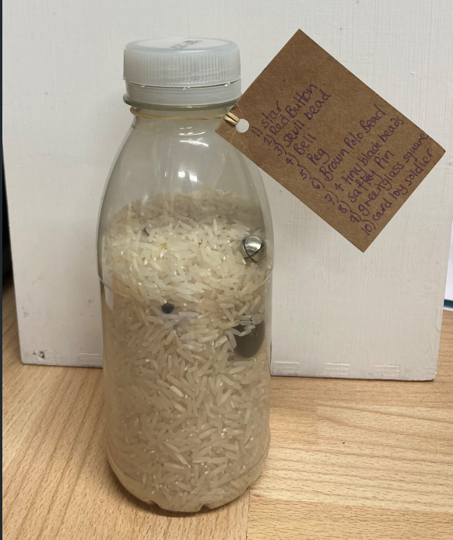

How to use your Mindful bottle

If you are feeling a little worried, stressed or angry.

Take your bottle and start to search for all the things on your list. You will need to twist and turn your bottle to be able to find all 10.

Some are big and easier to find some are smaller and hard to find.

Take your time and enjoy the experience of finding all 10.

When you have found them all you will feel calmer.

Mindful Bottle instructions