Helping your child at home with Phonics
At Churwell we teach phonics using a scheme called ‘Floppy’s Phonics’. This is an approved scheme for teaching systematic phonics throughout our Foundation Stage and Key Stage 1.
Phonics is the way in which we break down words into single sounds (phonemes) according to how they are written (graphemes) which are then blended together to read whole words.
The web page below helps to explain how phonics is taught.
https://www.oxfordowl.co.uk/for-home/advice-for-parents/phonics-videos

The phonemes and graphemes that we use are really important as we teach the children to make the ‘pure sounds’ correctly in order to read accurately. You can help at home by practising how to make these pure sounds with your child
Please click on the link to see and hear how each sound should be made.
https://youtu.be/UCI2mu7URBc

Children in Reception and Year 1 have daily, structured phonics lessons which follow the scheme tightly to enable children to accurately decode to read and encode to spell.
Phonics is also taught at the beginning of Year 2 and then continued for those children who may need additional time to develop their skills.
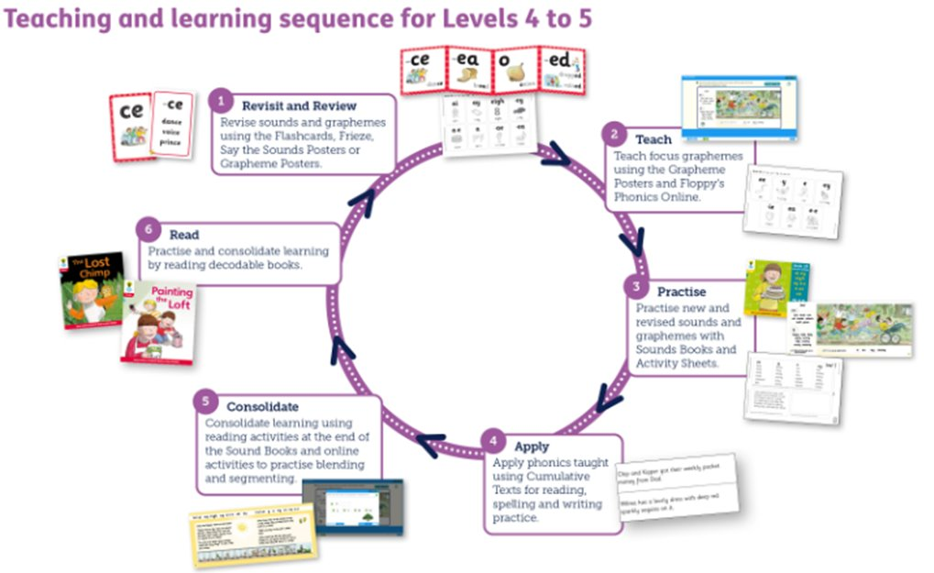
The scheme follows a teaching cycle which is repeated for each sound the children learn.

We hold annual parent meetings for children in Reception and Year 1 which give more information and ideas to you about the ways that you can help at home.

